April 8, 2023

Central Mississippi ARES

www.msares.com

Central Mississippi ARES   
Rapid Response

48 Hour Deployment Plan

# Version History

|  |  |  |  |  |  |
| --- | --- | --- | --- | --- | --- |
| **Version** | **Date** | **Editor** | **Approved Date** | **Approved By** | **Description** |
| v1.0 | 4/8/2023 | AEC Team |  |  | Initial Draft by AEC Team |
|  |  |  |  |  |  |
|  |  |  |  |  |  |
|  |  |  |  |  |  |
|  |  |  |  |  |  |

Table of Contents

Version History 1

Objective 3

Scope 3

Operational Goals 3

Logistical Goals 3

Operational Plan 4

Triggering Call To Action 4

Main Field Station 4

Roaming/Mobile Field Station 4

Home Station 4

Two Field Operators Per Shift Minimum 5

Initial Communications 5

Primary Communications - Winlink 5

Secondary Communications 6

Field Team Size and Shift Schedules 6

Staggered Deployment 8

Operational Equipment 9

Logistical Plan 10

Basics 10

Food and Water 10

Shelter 10

Safety 11

Transportation 11

Power 12

Latrine 12

Personal 13

# Objective

This document should provide a basic plan for the Central Mississippi ARES team to support a served agency in the field in a rapid response manner for a 48 hour period.

## Scope

The plan in this document should cover supporting a field operation outside the Central Mississippi ARES team’s home area, but within the State or nearby areas. Nearby areas would include approximately ~ 250 miles or ~ 4 hour drive time from Jackson, MS.

This plan should be able to be implemented within 6 hours of the request and include up to 48 hours of operation time from the initial deployment. Any needs beyond that period would need to transition to a longer term plan that can be prepared during this initial 48 hours.

This plan should cover the operational needs of providing communication support to the served agency.

This plan should also include logistical needs to support the members of the Central Mississippi ARES team members in the field.

# Operational Goals

Central Mississippi ARES serves at the request and discretion of the served agency. The operation is centered around providing communications for the served agency when basic public communication infrastructure is unavailable in the field.

The exact needs and requirements for each operation will vary.

A standard operation should provide the capability for an off-grid stationary field deployment that can pass traffic back to the home area and/or served agency headquarters that are on-grid and operational.

The standard deployment should also include a mobile resource that can provide local communication back to the stationary field deployment.

# Logistical Goals

Any operation, specifically a deployment, needs to consider the physical needs of the operators. This includes basic needs such as food, water, shelter. It also extends to things such as latrine/hygiene, power, fuel, transportation, lighting, etc… The Central Mississippi ARES team should be self sufficient and not cause a drain on limited served agency resources in the field. Of utmost importance is the safety of the team. If conditions in the field do not allow for safe operation, then the deployment should be recalled. The proper resources need to be available to execute a plan given the environmental conditions in a safe manner. If injury to the operators or damage to operational equipment happens in the field the team would become a hindrance to the served agency rather than an asset.

# Operational Plan

## Triggering Call To Action

An ARES response team or team member should never self deploy to any disaster area. We are to only deploy at the request of one of our partner agencies. This request will come through the chain of command within ARES.

ARES members who have completed a Level 2 certification will be notified via “GroupMe” message app or some other suitable messaging platform. Upon receiving notification of a call to activate a response team, team members will reply with their availability for the anticipated deployment duration and await assignment to deploy to a given location and time as well as mission specific details.

## Main Field Station

A temporary operating station should be set up near the served agencies center of operations in the field and should be capable of running “off-grid”. It should consist of an HF radio and a VHF radio (an HT may suffice). The HF radio and antenna should be able to contact Central Mississippi ARES team members operating back in the home area, and/or the served agency HQ if needed (MEMA for example). The VHF radio is for local communications with other operators deployed in the field including a roaming/mobile station. The role of the operator at the main field station is to provide a communication hub for the served agency field office and would be NCS for the deployment.

## Roaming/Mobile Field Station

This is a station that can be moved to various locations in the field. Depending on the size of the field this may be as simple as an operator with an HT, but may involve a vehicle with a 50 watt mobile installation. The role of this station is to provide coverage of the entire area the served agency is working on a rotating basis. It should be able to relay traffic from served agency representatives out in the field back to the Main Field Station. If this station is not needed at any time they can provide backup assistance to Main Field Station.

## Home Station

When there is a field deployment an HF station in the home area can aid in relaying traffic. This could be traffic from the main field station to its final destination and/or providing info back to the field either from served agencies or from ARES leadership. This lifeline between the field and home can help request needed resources or other help.

## Two Field Operators Per Shift Minimum

For any field deployment a minimum of two operators should be active per shift. This would provide a Main Field Station operator and a roaming field station operator for a minimal deployment. In larger deployments multiple operators could be used at the main field station, 1 for HF and 1 for VHF, and/or additional roaming field stations could be used. It is recommended that team members have at minimum General Class amateur radio privileges to serve as main field station operator.

## Initial Communications

Once a field station is set up, one of the first tasks should be to establish initial communications with the home station or HQ via Winlink then via voice. Use of MS Section net frequencies is recommended for initial contact. Ensure traffic can be sent and received by voice and/or Winlink.

## Primary Communications - Winlink

For a deployment where both the Main Field Station and Home Station(s) have Winlink capabilities, Winlink can be the primary channel of communication between the field and home. Winlink allows the field and home operators to use whatever band and gateway that is available given the current band conditions and equipment capabilities, to send and receive traffic to the system. It also allows for messages to be sent without the recipient being online at the time.

A distribution list of home station addresses and of the field station addresses to send traffic to would have to be pre-established prior to deploying.

A basic schedule would also need to be established prior to deployment about the expected send/receive rotation. For a minimal deployment with little traffic expected to be passed (at least initially) the main field station and the Home station would be expected to at least connect and send/receive messages once an hour. The Home station should schedule to connect at least at the top of every hour and the Main field station to connect at least at the bottom of every hour. While not the speediest of traffic passing this schedule should be able to be consistent and provide a mechanism to establish communication to/from the field. Once established it can be used to suggest other types of communications such as what band / freq /schedule should be attempted for HF voice communication based on field conditions.

If not all field operators have Winlink capabilities those that do should operate the initial shift and establish communication with Home, and use that communication to establish a voice net on a HF freq. Then the following shift the other operators can pass traffic on that voice net. With any HF net band conditions should be considered frequently and QSYs should happen as needed prior to the conditions getting too bad to communicate the QSY successfully.

## Secondary Communications

An HF Voice net should be established promptly in the deployment. While initial communications may be established via WinLink that can facilitate the coordination of optimal frequencies once that lifeline is established, it is good policy to have a plan in place in the event that WinLink is unavailable. It would be prudent to use the long established frequencies that the MS Section uses as a primary meeting point. Once communication is established, an appropriate QSY can be determined and coordinated given field conditions to optimize quality of traffic handling capabilities. The current MS Section frequencies are listed as follows;

3862 kHZ SSB (Primary)

7238 kHZ SSB

In addition to the 75/80M and 40M bands, certain conditions may require the use of other bands. On the 20M band, 14228 kHZ will be the initial communication frequency.

Establishment of initial communication should be attempted at 15 minute intervals beginning at the top of the hour.

In addition to WinLink and Voice nets, it would be advantageous to utilize the capabilities of NBEMS to efficiently pass traffic. The digital frequency used by the MS Section is 3581 kHZ using THOR 22 at 1000 on the waterfall and will be the standard for establishing initial communications.

## Field Team Size and Shift Schedules

A minimum of 2 field operators should be used per shift.

A shift should be no more than 2 consecutive hours.

An operator should take at least a 30 minute break between shifts.

An operator should only work 8 hours in a 16 hour span, then should be off for at least 8 hours.  
  
 For a 48 hour deployment operating around the clock this would require a minimum of 3 teams rotating.  
 For example a rotation like this would meet all criteria.

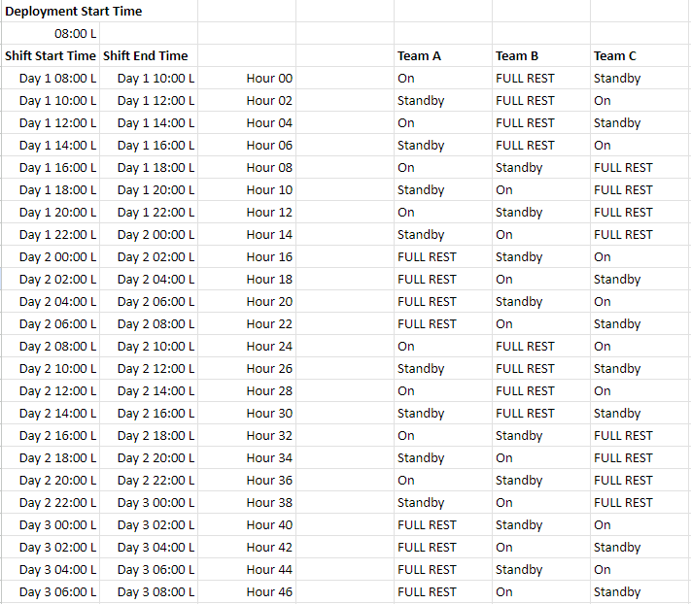

On is when the team is on shift and are the active operators in the field.

Standby is a shift where the team is not actively operating, but attending to any personal or logistical needs. If needed they can backup the on shift operators for short periods of time.

Full rest is just that, a continuous time where the team can rest and hopefully even sleep to prepare for their upcoming shifts and duties.

Note the schedule may impact logistics. With a single team on full rest it could be possible to share lodging arrangements aka “Hot Bunking”. A schedule where multiple teams are on full rest may require more lodging resources.

If 24 per day operation is not needed, and only “daylight” operations are needed then 2 teams would likely suffice, but lodging for both teams would be needed for “dark” hours.  
  
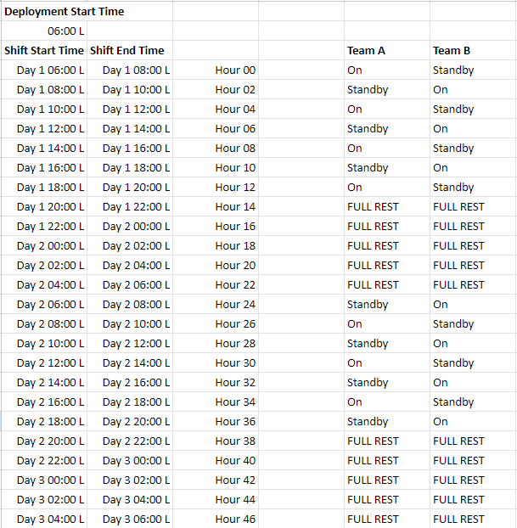

## Staggered Deployment

Depending on the schedule and number of active teams at the beginning of a deployment schedule, it may be possible for teams within the deployment group to deploy to the field in a staggered pattern. For example in the previously shown three team schedule, team B starts the schedule with eight hours of full rest. Rather then deploying and immediately trying to rest it may be advisable for them to simply deploy at a later time such that they arrive in time to setup and prepare for their scheduled shifts

This has a few advantages. First it is often easier to rest at home than in the field. Second, it may allow for additional participation in the deployment. Some members may not be available to immediately deploy. The delay in their deployment may allow for their availability that simply wasn’t possible at the beginning of the deployment. That additional time can allow for taking care of family needs, finding child care, etc, to free up that member for deployment. Last but not least it can allow for a critical re-supply to the field. If the initial teams deploy and discover they are missing something or have a limited supply of a needed resource, communications back to the home area should have been established and the staggered team can deliver request/additional supplies if needed.  
  
One thing to keep in mind is that if a team is staggered for a deployment like this, they will be expected to work their shifts when they arrive which could be a full day in itself, so that team should use the extra time to rest as best as possible to provide fresh energy to the deployment when they arrive.

A staggered deployment plan can also be extended to swapping out teams. If overnight logistics are problemsome and proximity to the field allows for it, swapping out teams may allow for each team to work 24 hour or 16 hour deployments. Essentially the full rest periods for each team would be the target window to swap out teams. You don’t want to allow a team to leave the field until you are sure the replacement team is en route or possibly even on site.

## Operational Equipment

The basics needed for each shift in the field is an HF transceiver, and 2 VHF transceivers (1 stationary, and the other roaming/mobile). In many cases HTs will suffice for the VHF transceivers, but 50 watt mobiles are nice, especially with crossband repeat in conjunction with HTs. Antennas are obviously needed as well to support the bands and power to match operational needs. This would include whatever is needed to deploy the antenna, tripods, masts, rope, launchers, etc… Multiple antenna options may be needed as the environment in the field may be unknown and there may or may not be trees or other structures to aid in raising antennas. Multiband, self sufficient setups are preferred. Of course power is the other critical component. Enough battery capacity to handle multiple shifts will be needed, and if enough battery capacity is not brought to handle the full schedule charging capabilities will be needed. Solar is nice, but may not be usable depending on conditions, so a generator would be a required item in that scenario. With Winlink (or other digital modes) in the operational plan then a computer and any required cabling or TNC/soundcard devices to operate will be required. Then there are all the other connecting pieces of coax, adapters, couplers, etc… Last but not least, optional components like tuners, meters, etc can be brought as well to complete a station.

At this time each operator would be expected to bring their own equipment. Perhaps each team can coordinate to determine and only bring 1 setup per role, but any operator using the station should be familiar with that radio and station setup. This can be particularly difficult when you start talking about digital setups and if you are sharing a radio, but not the laptop that goes with it, then does all laptops have the right drivers, etc…  
  
 Items such as a generator could likely be shared across the teams and used to charge batteries while a team is on standby or rest, but would need to be coordinated for capacity, charging times, and fuel considerations.  
  
 In the future an Central MS ARES “trailer” with all resources provided would reduce overall resources needing to be brought to the field, but training on that specific setup would be needed for each operator before deploying to the field.

# Logistical Plan

## Basics

The Central Mississippi ARES team should deploy with the expectation of being self sufficient. We do not want to add an unwanted drain on resources of the served agency. It also allows us to tweak provisions to our tastes as desired.

## Food and Water

Two of the basic needs of life. As a rule of thumb 2 gallons of water per person per day should be provisioned for the deployment. Water allows for drinking, cooking, and cleaning. In more extreme weather, specifically heat, additional water should be provisioned.

As a minimum basic “rations” for 3 meals per day per person should be provisioned. Traditional MREs or more modern Mountain House (dehydrated) meals are simple ways to portion and provide easy to transport food. The water that has already been mentioned can be used to rehydrate these meals, and combined with a small camp stove and container can make hot filling meals quickly and simply.

Of course food provisions can be upgraded if decided, but for simplicity and storage, the basic plan would be to use the dehydrated or other shelf stable food products.

For drinking water and if any upgraded perishable food is provisioned it may be desired or required to bring a cooler or a 12v portable fridge to keep things cool. Ice in a cooler will only last so long and 12v portable fridges require additional power, so use with caution if you go that route.

## Shelter

Shelter is another basic human need that the Central Mississippi ARES team will need to provision. This will include any lodging arrangements as well as operating needs to protect from environmental concerns.  
  
 A minimal setup would be simple camping style tents for lodging of the entire deployment team and a tailgate style tent or two to operate from.

The main priority of shelter is to protect from environmental conditions, so the weather and environment of the field should be considered heavily. Will it be hot and sunny or cold and windy? Is rain expected or possible, snow, hail, tornadoes? In some cases will an operator's vehicle provide better shelter than a tent?  
  
If resources are available travel trailers / RVs / expedition vehicles can be ideal, but obviously have capacity limitations and likely are not available to all members of the team. Once again shelter will at this time will have to be provided by the operators themselves until additional resources can be acquired by the team.

## Safety

**Safety First Safety First Safety First**

Safety The safety of ARES members is a prime concern. Training on safety topics is likely to be very specific to the particular hazards in your local jurisdiction. Many parts of the country experience severe weather, and SKYWARN training often includes components on staying safe during these events. In some locales, training on hazardous materials or radiological hazards could be important. Additional training in land navigation and wilderness safety may be necessary for ARES groups that assist search and rescue teams. ECs should consider the potential hazards of their area; of course make plans to avoid them, but also a plan of appropriate training for the ARES members.

If you are deployed it is important the leadership, be it the County E.O.C., the Sheriffs Office, City Police Dept. or even the local Fire Dept., know you are on site and verify the location you intend to set up is clear for access.

Personal safety is a must so be sure you have clothing for the time of year, proper shoes or boots, vests, even your hard hat.

See the ARES Field Deployment checklist for the 48-hour “Go-Kit” .

A good ground is key for any portable station. If needed use your jumper cables to connect to a fence or metal pipe then to your station. Any ground is better than no ground.

When possible keep your vehicle close. It can be a shelter or a means of exit.

## Transportation

Each team member will be responsible for transportation to and from the deployment area. Team members assigned in pairs may elect to carpool to cut down on expenses. Your vehicle should be capable of carrying you and all equipment, supplies, and gear.

In the future it may be possible to procure an enclosed team trailer that contains all the necessary equipment and would be available for deployment with trained team members.

## Power

Each response team member will be responsible for the power required to operate their own equipment for their assigned shifts. Ideally that would consist of sufficient batteries to operate the entire 48 hour deployment. Given the cost and weight of a large bank of batteries, it might be more feasible to recharge the batteries using solar and or gasoline powered generators. To reduce weight, it is advisable to use LiFePO4 (lithium iron phosphate) batteries whenever possible.

In addition to radio equipment, there are some other equipment which could prove useful in a deployment that will need power. Some examples are:

Lights

Fans

Coffee pot (essential to the morale of the team)

Team members may elect to share the more bulky or heavy items to save time and energy, such as only bringing one generator and the corresponding gasoline tanks to maintain its use.

Team members should have provisions for connecting their equipment to a power source using the ARES standard Anderson Power Pole connectors whenever possible. This should provide compatibility between operators and the ability to share power resources with other team members.

## Latrine

The call of nature cannot be ignored even in a deployment situation. Depending on the scenario “facilities” may not be readily available. In the vein of being self sufficient the deployment team should be prepared to heed the call of nature in a responsible manner.

Those with camping experience will likely lean to the trusty shovel and a roll of toilet paper. While that may work for a wilderness outing deployments will likely be to more populated areas simply struggling from a storm or other event. In this scenario a personal porta-potty is the way to go (pun intended) and provides a way to pack out what you pack in. Even in a wilderness situation animals will often dig up what is left which can lead to undesirable litter if not packed out. Hear me out here. This system consists of 3 parts.  
  
First a privacy tent of some sort, a portable / folding toilet seat, and a waste “kit”.  
  
The real key is the waste kit/bags that are available today. You secure the bag to your toilet and do your business. In the bag are chemicals that gel or otherwise solidify liquid waste and help absorb odors.Once you are done with the bag it will seal and/or you place it into a larger sealable bag and add it to the general waste for your site that should be packed out and disposed of ethically.

Here are some links to products I would suggest in addition to your basic toilet paper and hand sanitizer. Shop around ,there are a variety of vendors, manufacturers, models, etc that will get the job done, but I have used these with my family while camping and can verify this setup would work well in a deployment situation.  
  
  
Privacy Tent:  
<https://www.amazon.com/WolfWise-Privacy-Portable-Changing-Dressing/dp/B01AT3T0GC/ref=asc_df_B01AT3T0GC/?tag=hyprod-20&linkCode=df0&hvadid=198081946947&hvpos=&hvnetw=g&hvrand=565229745616709117&hvpone=&hvptwo=&hvqmt=&hvdev=c&hvdvcmdl=&hvlocint=&hvlocphy=9013908&hvtargid=pla-320110839321&th=1>  
  
Portable Toilet Seat:  
<https://www.amazon.com/dp/B001TKGAKO?linkCode=ssc&tag=onamzlifestyo-20&creativeASIN=B001TKGAKO&asc_item-id=amzn1.ideas.1NKETGXOLK3GF&ref_=aip_sf_list_spv_ofs_mixed_d_asin&th=1>

Waste Kits:  
<https://www.amazon.com/Go-Anywhere-Toilet-Kit-12-pack/dp/B001P6ZFG2/ref=pd_bxgy_sccl_1/132-1951220-3792368?pd_rd_w=fCXJg&content-id=amzn1.sym.6ab4eb52-6252-4ca2-a1b9-ad120350253c&pf_rd_p=6ab4eb52-6252-4ca2-a1b9-ad120350253c&pf_rd_r=5EPPKRTT7HMWSE7AQ8HJ&pd_rd_wg=mrIsb&pd_rd_r=acd591b5-8db6-4c49-9228-bbf873a3d1ce&pd_rd_i=B001P6ZFG2&psc=1>  
or  
<https://www.amazon.com/dp/B07X3Y827R?linkCode=ssc&tag=onamzlifestyo-20&creativeASIN=B07X3Y827R&asc_item-id=amzn1.ideas.1NKETGXOLK3GF&ref_=aip_sf_list_spv_ofs_mixed_d_asin&th=1>

Once again each member is responsible for their own equipment and needs, but at least the tent and toilet are items that could be a group resource if needed and for simplicity. In that scenario I would recommend each member supply their own waste kits.

## Personal

The theme of self sufficiency is found throughout this plan. Each member is responsible for their own equipment, not just operationally, but more logistical items like bedding, clothing, cookware, etc…

Every individual has their own personal needs and preferences. During your standby and off duty times, you likely will need to decompress for a little while, particularly if the situation is stressful. As with any disaster recovery, there will likely be limited resources for entertainment. A book or a deck of cards may be helpful for relaxation. If you have a favorite pillow, teddy bear or such comfort needs, make sure you bring them.

A go-kit is meant to be minimalistic, but obviously an expanded list of items can provide more comfort and redundancy. Keep this in mind when preparing kits, meet NEEDs first and comfort second.

Please see the attached GO KIT list for more suggestions on packing personal items.

# Appendix A: GO KIT Checklist

|  |  |
| --- | --- |
| **ARES Field Deployment Checklist for 48-hour "Go-Kit"** | |
| **Basics Kit** | |
|  | Tool kit with multi-meter and gas or DC soldering iron, solder |
|  | Electrical and duct tape |
|  | Power supplies |
|  | Extension cords, plug strips |
|  | Deep cycle or gel-cell (sealed lead-acid) battery |
|  | Battery charger(s) |
|  | SWR meter, (VHF, HF) |
|  | Tuner |
|  | Standard power connectors and adapters (30 amp PowerPole and the older Molex 1545) |
|  | Alkaline and rechargeable batteries |
|  | Flashlights, lanterns, worklights & spare batteries and bulb |
|  | ARES ID card, driver’s license, other relevant IDs |
|  | Zipties |
|  | Duct tape |
|  | Axe/Chainsaw |
|  | Shovel |
|  | Hammer |
|  | Table |
|  | Chairs |
|  | Hazard lights |
| **VHF/UHF Kit** | |
|  | 2-meter/dual band handheld transceiver and speaker/mic |
|  | 2-meter/dual band mobile transceiver |
|  | 2-meter/dual band magnetic mount antenna and/or base antenna with support |
|  | Earphone or headset |
|  | RF and audio connectors and adaptors |
|  | Extra coaxial cables |
|  | Alkaline battery pack for hand-held radio |
| **HF Kit** | |
|  | HF transceiver |
|  | Tuner |
|  | Antennas, supports, launchers |
|  | Feed lines |
| **Operating Supplies Kit** | |
|  | Paper and pencil, sharpener |
|  | ARRL-ICS-213, Radiogram forms |
|  | Message forms |
|  | Logbook |
|  | Phone lists, contact information, ARES plan info |
|  | Net scripts |
|  | Net logs |
|  | Incident report templates |
| **Winlink/Digital Kit** | |
|  | Laptop computer, DC power cable |
|  | Patch cords |
|  | Packet modem and/or sound card mode interface, other gear for specialized modes |
| **Personal Needs Kit (48 Hours)** | |
|  | Appropriate clothing for the season |
|  | Foul weather gear |
|  | Food and water for 48 hours (2 gal water per person, per day) |
|  | Toilet kit (including toilet paper!) / Clean waste kit |
|  | Shelter (tent) |
|  | Sleeping bag, foam pad, and a real pillow |
|  | Portable stove, mess kit and cleaning supplies |
|  | Waterproof matches |
|  | First aid kit and pain relievers |
|  | Throat lozenges |
|  | Prescription medicines, eyeglass prescription copy, spare eyeglasses |
|  | Money, change for tolls and vending machines |
|  | Fan |
|  | Alarm clock (portable wind up or battery type) |
| **Add-on Kit for Extended Deployment (72 Hours)** | |
|  | 3 day change of clothes |
|  | 3 day supply of water, food, snacks |
|  | Additional forms and pencils, other expendable supplies |
|  | Additional batteries |
|  | Generator, lighting, extension cords, fuel can |
|  | Fuel |
|  |  |